*Assignment No2*

**Q1**

**Ans**

**package** Assignment2;

**public** **class** Sumnaturalnumber {

**public** **static** **void** main(String[] args) {

**int** sum=0;

**for**(**int** i=1; i<=10; i++) {

sum = sum +i;

}

System.***out***.println(sum);

}

}

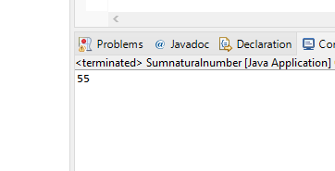

Q2

Ans

**package** Assignment2;

**import** java.util.Scanner;

**public** **class** Multiplication_Table {

**public** **static** **void** main(String[] args) {

Scanner s = **new** Scanner(System.***in***);

System.***out***.println("Enter a positive number :");

**int** n = s.nextInt();

**for** (**int** i = 1; i<= 10; i++)

{

System.***out***.println(n+"*" + i + "=" + n * i);

}

s.close();

}

}

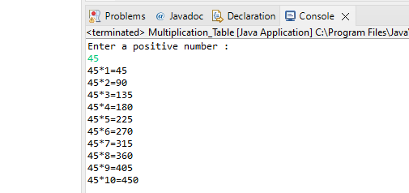

Q3

Ans

**package** Assignment2;

**import** java.util.Scanner;

**public** **class** Reverse_number {

**public** **static** **void** main(String[] args) {

Scanner s = **new** Scanner(System.***in***);

**int** num , rev = 0;

System.***out***.println("Enter the number :");

num = s.nextInt();

**while**(num != 0)

{

**int** digit = num% 10;

rev = rev *10 + digit;

num /=10;

}

System.***out***.println("Reversed Number : " + rev);

s.close();

}

}

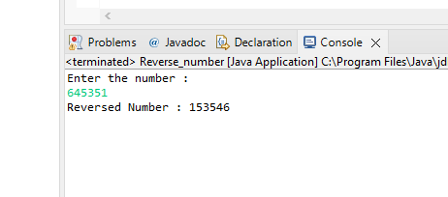

**Q4**

**Ans:**

**package** Assignment2;

**import** java.util.Scanner;

**public** **class** permission {

**public** **static** **void** main(String[] args) {

Scanner console = **new** Scanner(System.***in***);

**int** number1, number2;

**char** choice;

**do**

{

System.***out***.print("Enter the first number ");

number1 = console.nextInt();

System.***out***.print("Enter the second number ");

number2 = console.nextInt();

**int** sum = number1 + number2;

System.***out***.println("Sum of numbers: " + sum);

System.***out***.print("Do you want to continue y/n? ");

choice = console.next().charAt(0);

System.***out***.println();

}**while**(choice=='y' || choice == 'Y');

}

}

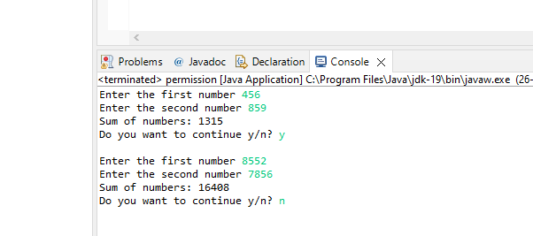

Q5

Ans:

**package** Assignment2;

**import** java.util.Scanner;

**public** **class** armstrong {

**public** **static** **void** main(String[] args) {

// **TODO** Auto-generated method stub

**int** n,a,b,c;

**int** count = 0;

**int** sum = 0;

System.***out***.println("The desired armstrong numbers are :");

**for** (**int** i=1; i<=500; i++)

{

n=i;

**while**(n>0)

{

b = n%10;

sum = sum + (b*b*b);

n = n/10;

}

**if**(sum ==i)

{

System.***out***.print(i + " ");

}

sum =0;

}

}

}

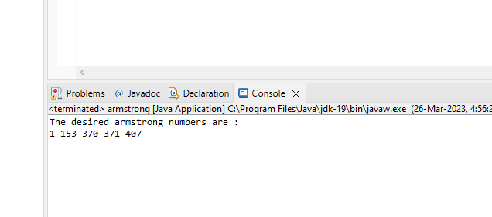

Q6

Ans:

**package** Assignment2;

**import** java.util.Scanner;

**public** **class** Fibonacci {

**public** **static** **void** main(String[] args) {

Scanner s = **new** Scanner (System.***in***);

System.***out***.println("For how many times,you want to print Fibonacci series");

**int** n = s.nextInt();

**int** a=0;

**int** b=1;

**int** c=0;

System.***out***.println(a);

System.***out***.println(b);

**for**(**int** i=1;i<=n-2;i++)

{

c = a+b;

System.***out***.println(c);

a=b;

a=c;

}

}

}

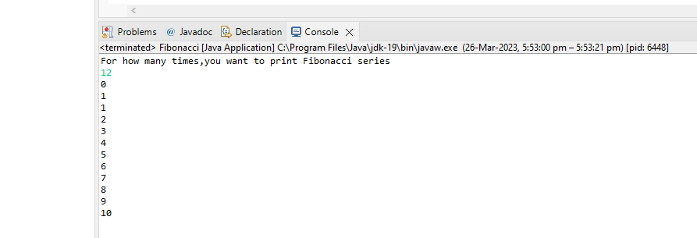

Q7

Ans:

**package** Assignment2;

**public** **class** Ques7_1 {

**public** **static** **void** main(String[] args) {

**for** (**int** i=1;i<=4;i++)

{

**for**(**int** j=1;j<=10;j++)

{

System.***out***.print("*");

}

System.***out***.println();

}

}

}

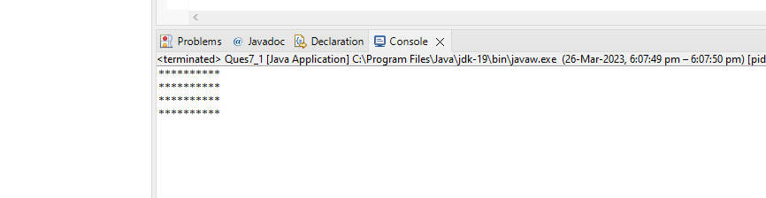

Q7

Ans

**package** Assignment2;

**public** **class** Ques7_2 {

**public** **static** **void** main(String[] args) {

**for** (**int** i=1;i<=5;i++)

{

**for**(**int** j=1;j<=i;j++)

{

System.***out***.print("*");

}

System.***out***.println();

}

}

}

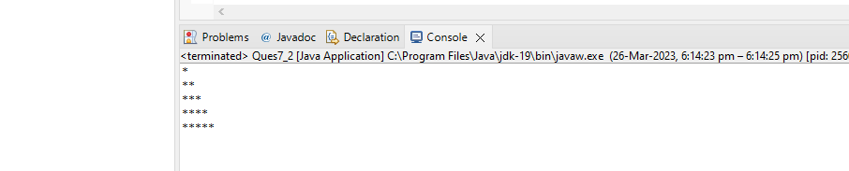

Q7

Ans

**package** Assignment2;

**public** **class** Ques7_3 {

**public** **static** **void** main(String[] args) {

**for** (**int** i=1;i<=5;i++)

{

**for**(**int** j=5;j>i;j--)

{

System.***out***.print(" ");

}

**for**(**int** k =1;k<=i;k++)

{

System.***out***.print("*");

}

System.***out***.println("");

}

}

}

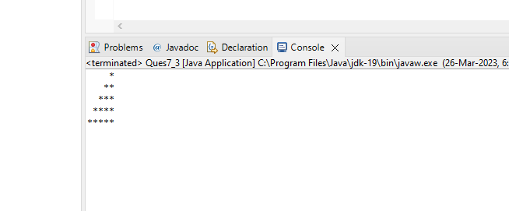

Q7

Ans

**package** Assignment2;

**public** **class** Ques7_4 {

**public** **static** **void** main(String[] args) {

**for**(**int** i=1;i<=9;i=i+2)

{

**for**(**int** j=9;j>i;j=j-2)

{

System.***out***.print(" ");

}

**for**(**int** k=1;k<=i;k++)

{

System.***out***.print("*");

}

System.***out***.println(" ");

}

}

}

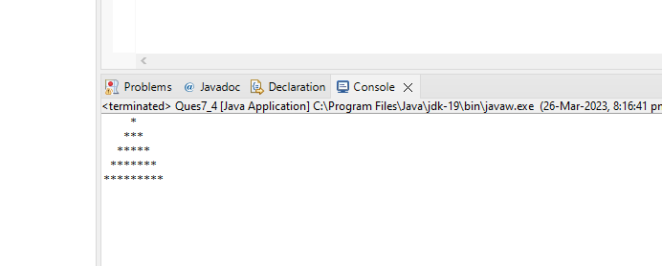

Q7

Ans

**package** Assignment2;

**public** **class** Ques7_5 {

**public** **static** **void** main(String[] args) {

**int** var =1;

**for**(**int** i=1;i<=9;i=i+2)

{

**for**(**int** j=9;j>i;j=j-2)

{

System.***out***.print(" ");

}

**for**(**int** k=1;k<=i;k++)

{

System.***out***.print(var);

}

var++;

System.***out***.println("");

}

}

}

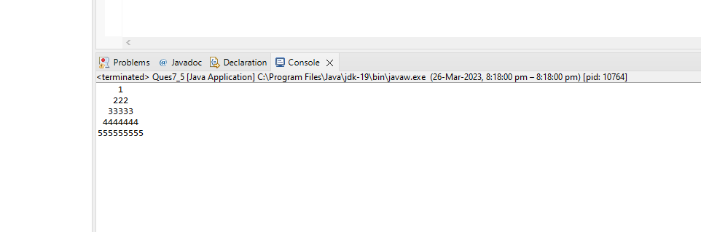

Q7

Ans

**package** Assignment2;

**public** **class** Ques7_6 {

**public** **static** **void** main(String[] args) {

**int** z= 71;

**int** space =-1;

**char** x= 'F';

**for** (**int** i =1;i<=5;i++)

{

z--;

**for**(**char** a='A';a<z;a++)

{

System.***out***.print(a);

}

space++;

**for**(**int** j=2;j<=space+1;j++)

{

System.***out***.print(" ");

}

**for**(**int** j=2;j<=space+1;j++)

{

System.***out***.print(" ");

}

x--;

**for**(**char** b=x;b>='A';b--)

{

System.***out***.print(b);

}

System.***out***.println();

}

}

}

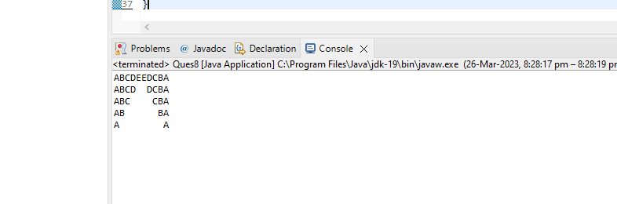

Q8

Ans

**package** Assignment2;

**import** java.util.Scanner;

**public** **class** Ques8 {

**public** **static** **void** main(String[] args) {

Scanner s=**new** Scanner(System.***in***);

System.***out***.println("Enter Number");

**int** n= s.nextInt();

**int** even =0,odd=0;

**do**

{

**int** p=n%10;

n=n/10;

**if**(p%2==0)

{

even = even+p;

}

**else**

{

odd =odd+p;

}

}

**while**(n!=0);

System.***out***.println("Sum of the even numbers"+even);

System.***out***.println("Sum of the odd numbers"+odd);

}

}

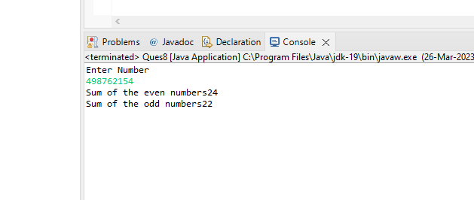

Q9

Ans

**package** Assignment2;

**import** java.util.Scanner;

**public** **class** Ques9 {

**public** **static** **void** main(String[] args) {

Scanner s=**new** Scanner (System.***in***);

System.***out***.print("Enter Number");

**int** a= s.nextInt();

**for**(**int** i=2;i<a;i++)

{

**if**(a%i==0)

{

System.***out***.print("Not a prime number:");

System.***out***.println();

**break**;

}

**else** **if**(i==a-1)

{

System.***out***.println("Prime Number");

}

}

}

}

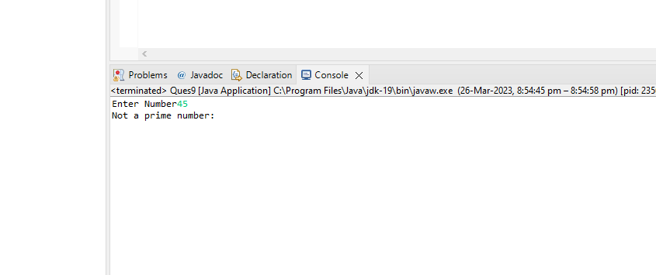

Q10

Ans

**package** Assignment2;

**import** java.util.Scanner;

**public** **class** Quest10 {

**public** **static** **void** main(String[] args) {

System.***out***.print("Prime Numbers Between 2 to 20");

**for**(**int** i=2;i<=20;i++)

{

**for**(**int** j=2;i<=20;i++)

**if**(i!=j&&i%j!=0)

{

System.***out***.print(i);

System.***out***.println();

**break**;

}

}

}

}

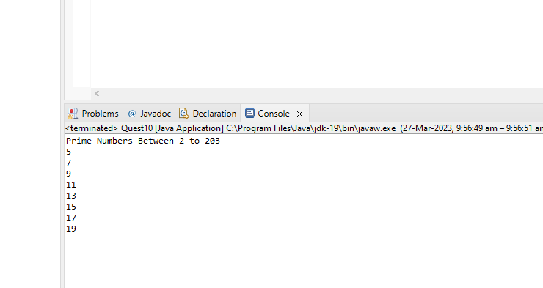

Q11

Ans

**package** Assignment2;

**import** java.util.Scanner;

**public** **class** Ques11 {

**public** **static** **void** main(String[] args) {

Scanner s=**new** Scanner(System.***in***);

System.***out***.print("Enter First Number:");

**int** a=s.nextInt();

System.***out***.print("Enter Second Number:");

**int** b=s.nextInt();

System.***out***.print("Enter Third Number:");

**int** c=s.nextInt();

**int** result = (a>b ?(a>c?a:c):(b>c?b:c));

System.***out***.print("Greatest Number is:"+result);

}

}

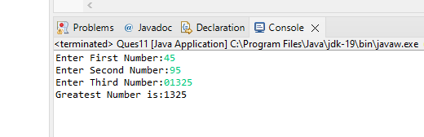

Q12

Ans

**package** Assignment2;

**import** java.util.Scanner;

**public** **class** Ques12 {

**public** **static** **void** main(String[] args) {

**int** a=0;

**for**(**int** i=100;i<=200;i++)

{

**if**(i%7==0)

{

a=a+i;

}

}

System.***out***.println("Sum of the 100 to 200 numbers that divided by 7 is:"+a);

}

}

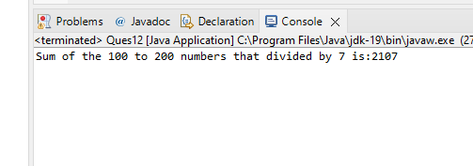

Q13

Ans

**package** Assignment2;

**public** **class** Ques13 {

**public** **static** **void** main(String[] args) {

System.***out***.println("Following Numbers Divided by 3 and 5:");

**for**(**int** i=1;i<100;i++)

{

**if**(i%3==0&&i%5==0)

System.***out***.print(i+",");

}

}

}

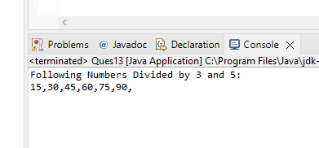

Q14

Ans

**package** Assignment2;

**import** java.util.Scanner;

**public** **class** Ques14 {

**public** **static** **void** main(String[] args) {

Scanner s=**new** Scanner(System.***in***);

System.***out***.print("Enter First Number:");

**int** m=s.nextInt();

System.***out***.print("Enter First Number:");

**int** n=s.nextInt();

System.***out***.println("Menu 1 Add\n 2 substract\n 3 Multiply\n 4 Divide");

**int** a=s.nextInt();

**switch**(a)

{

**case** 1 : System.***out***.println("Addition :"+(m+n));

**break**;

**case** 2: System.***out***.println("Substraction: "+(m-n));

**break**;

**case** 3: System.***out***.println("MUltiply :"+(m*n));

**break**;

**case** 4: System.***out***.println("Divition: "+(m/n));

**break**;

**default** :System.***out***.println("Wrong Entry:(");

}

s.close();

}

}

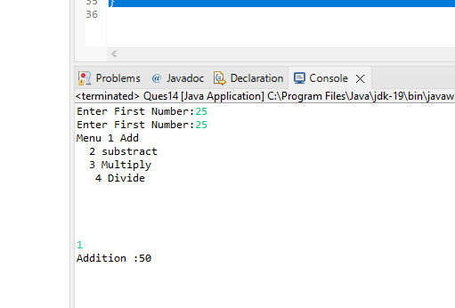

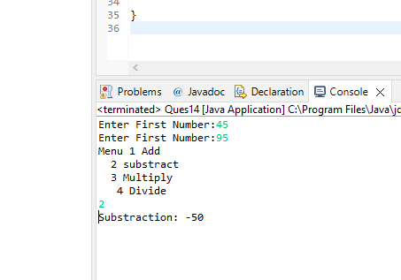

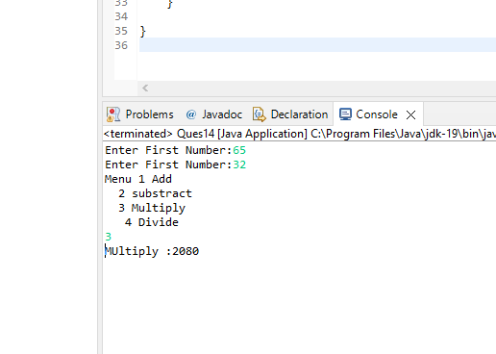

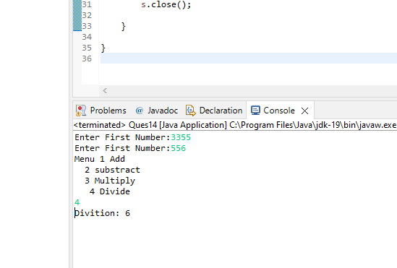

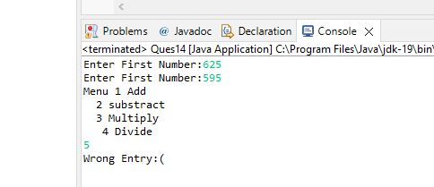

Q15

Ans

**package** Assignment2;

**public** **class** Ques15 {

**public** **static** **void** main(String[] args) {

**for**(**int** i=1;i<=20;i++)

{

**if**(i%2==0&&i!=16)

{

System.***out***.print(i+",");

}

**else** **if**(i==16)

{

**break**;

}

}

}

}

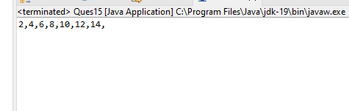

Q16

Ans

**package** Assignment2;

**import** java.util.Scanner;

**public** **class** Ques16 {

**public** **static** **void** main(String[] args) {

Scanner s=**new** Scanner(System.***in***);

System.***out***.print("Enter Number:");

**double** a=s.nextDouble();

System.***out***.print("Enter Number:");

**double** b=s.nextDouble();

**if**((a>0&&b>0)&&(a<1&&b<1))

{

System.***out***.println("Entered Numbers is in between 0 To 1");

}

**else**

System.***out***.println("Entered Numbers is NOT in between 0 to 1");

}

}

